Background

Introduction
As part of our objective to become a green port champion in the Pacific region, we further decided to extend our reach to the far and wide community in our country to foster a dialogue for another important initiative in waste management particularly in plastic waste. With this holistic approach, Solomon Ports began to expand our port-community dialogue on the 3R campaign to make a change in the society to be aware of the depletion of resources, the need to reduce our usage and recycle as much as we could to reduce our impact to the environment, we live in.

Though we understand that we cannot stop waste production entirely, but everyone can make a significant contribution to reduce it. Think before you bin! It saves energy and natural resources, helps to reduce pollution and reduces the need for landfill. The 3R (Reduce-Reuse-Recycle) Concept is a sequence of steps on how to manage waste properly. The top priority is to reduce, which is to reduce waste generation, then Reuse, and then Recycle, to give waste material a second chance before disposing them to the landfill.

As waste management is a critical issue for the city of Honiara, Solomon Ports is taking this initiative to encourage members of the public in Honiara to practice proper waste disposal manners. Kicking off this project we installed rubbish bins along some of the busy streets, in and around the Port and city, and schools as a start to introduce this concept to our people. We specifically wanted to target children at schools to instill the good habit of taking care of the environment at an early stage of their lives.

All disposal bins have been outfitted with signs to distinguish between ‘General Waste, Cans, bottles, plastic and food waste and 3R signboards have been erected in several places in the city and port to create awareness on the project.

Solomon Ports is taking the lead in tackling this issue, and would like to encourage all organizations, companies, and individuals of Solomon Islands to adopt this initiative, so that it becomes part of their lifestyle. The project will be further extended to recycle plastic waste and compost all degradable materials city wide.

Overarching Principle
The 3R Campaign of Solomon Ports has linked to the following Principles adapted from the Solomon Islands Waste Management and Pollution Control strategy 2017-2026

Sustainable Development
Sustainable development requires that waste management be carried out in a way that does not place undue social, economic, or environmental burdens on either present or future generations.

Waste hierarchy
This strategy acknowledges and promotes the Waste Hierarchy principle that includes the 3R concept: Reduce, Re-use, Recycle. Waste minimization through reduction, separation at source, reuse and recycling prevents the creation of wastes and reduces the quantity and the impacts of waste that is generated.

Sustainable Production and Consumption
This strategy encourages all businesses in the country to develop production and consumption cycle on a sustainable basis. They must take on the responsibility to go beyond waste itself and to consider instead the source of waste, i.e., the demand for goods and services and the productive activity that is undertaken to meet that demand.

Consultation principle
Government and stakeholders at all levels will consult and work with people and organizations throughout the development and implementation of the waste management strategies and action plan.

Problem Analysis

Solomon Islands Waste Challenge

According to an Asian Development Banks report in June 2014 on key points for action to address challenges facing Solomon Islands related to solid waste management states that the total solid waste generation rate (household and non-household) for Solomon Islands is estimated to be 0.75–1.0 kilogram (kg) per person per day. With a population of around 80,000 and a waste generation rate of 1.0 kg/person/day, the Honiara urban area is estimated to generate 80 tons per day or 29,000 tons per year. It is estimated that 20 to 30 tons of solid waste is disposed of daily at the dumpsite without proper waste segregation. There are no awareness campaigns that seek to educate the public, or even the government, about the health consequences of burning trash and of other improper waste management practices, and limited information available to the public to
support improved transparency and accountability in the management of solid waste. Even though, there is a solid waste management strategy in placed, it still requires an enabling environment for the capacity building and adequate financial stability for the sustainability of the system.

Below is a data representation of the waste characterization study undertaken by Sinclair Knight Merz (SKM) in 1990 and was the first to be undertaken for Honiara landfill and represents the baseline solid waste data for Honiara. Proportion of Plastic material accounts for 16 % while biodegradable materials highest with 65 %.
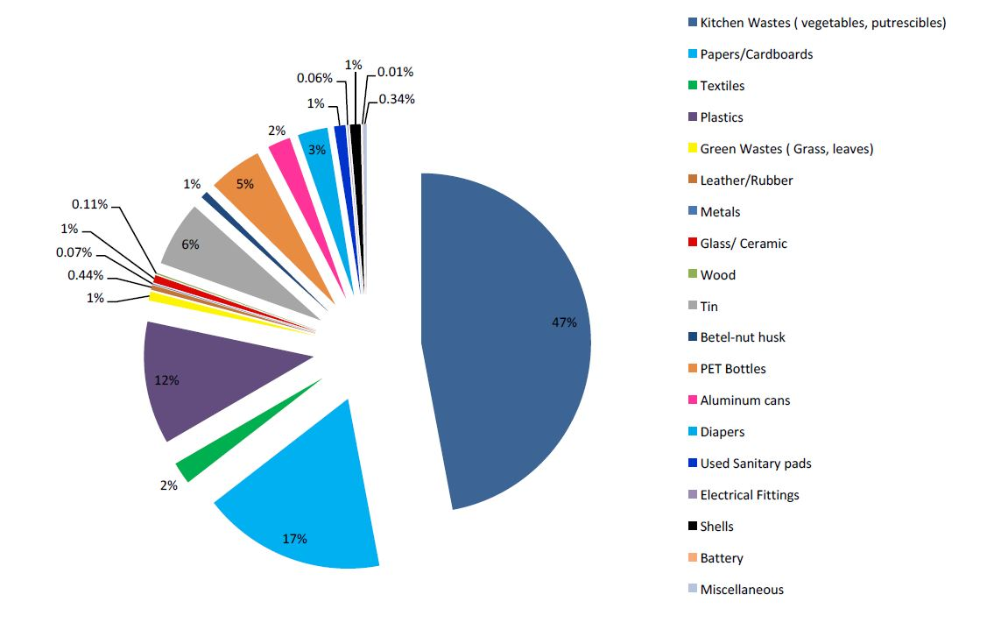

Source: Solomon Islands National Waste Management and Pollution Control Strategy 2017-2026, (2017)

Recently in 2015, another joint initiative between the Secretariat of the Pacific Regional Environment Programme (SPREP) and the Ministry of the Environment, Climate change and Disaster and Meteorology (MECDM) was taken up on a riverbank in Honiara Town called Mataniko River with a baseline data showing the waste compositions generated. Waste is collected using boom demonstration.
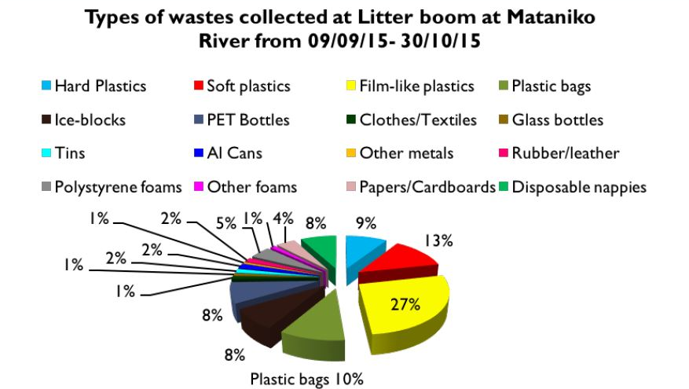

Source: Solomon Islands National Waste Management and Pollution Control Strategy 2017-2026, (2017)

Solomon Ports 3R (Reduce, Reuse, Recycle) Campaign Project Proposal
As part of the transformational journey towards becoming a green port and a climate change advocate in the Pacific, Solomon Ports have been pursuing number of sector initiatives based on the 3R concept adopted organization wide. Solomon Ports recognizes that without appropriate planning, consumed resources and materials may ultimately end up as wastes and pollution, imparting negative impacts to land, water, air, human health, and the global environment. It is therefore a need to invest on 3Rs (Reduce, Reuse and Recycle) for the improvement of waste management, resource efficiency and public health as our social obligation towards community outreach and port-city dialogue.

For the First 3-year plan 2021- 2023 of our project since commissioning the 3R Campaign in January 2021, the First phase of the campaign for the coming 9-month Action Plan sets on Education and Awareness on Waste management through proper waste disposal and waste minimization.

Project Impact: Good Health and well-being of all citizens of Solomon Islands through proper waste management practice, education, and awareness.

Outcome 1: School Waste Management Plan Improved

1.1 Output:
1.1.1 Waste Disposal Sites Constructed in 6 selected schools in Honiara (Tamlan High School, St. John Highschool, Woodford International School, Coronation Highschool, Florence Young High School, St. Nicholas College) including additional 5 schools in 5 Major Provinces as part of the campaign expansion.
1.1.2 Waste management embedded into schools’ best practices.

Activities:
    - Construction of waste disposal sites at 6 selected schools with distinguishing waste separations signage, (General Waste, Recyclable (Cans, plastics, glass bottles), Food Wastes (Biodegradables)
      - Pictures of types of wastes placed on each dedicated bin for school children to understand the different waste streams.
    - Providing Awareness to the school on the importance of Proper waste management and waste segregation at the early stage of waste generation

Outcome 2: Student’s knowledge on waste management increased.

2.2 Output:
2.2.1 Schools Intervention Programs begins

Activities:
2.2.1.1 Identify each School students 3R Concept Champions (2 boys, 2 girls- from Primary and secondary level respectively
2.2.1.2 Green Champion Badges and certificates to be given to Champions annually with attractive awards of work recognitions.
2.2.1.3 Conduct joint meetings with all champions to understand how they are doing and their challenges.
2.2.1.4 Conduct School Contest
2.2.1.4a Art contests/ quiz contest / radio programs
2.2.1.4 Inter- school debates & Price Giving donations
2.2.1.5 Solomon Port’s Unity Square to be used as a showcase Venue for Students during World Environmental Day and all other relevant annual events.

Outcome 3: Sustainable Port through Energy efficiency and waste minimalization
Output 3.1
Output 3.1.1 Employees taking up responsibility and ownership to minimize waste generations in operation.
Output 3.1.2 Workshops conducted, increased number of employees awareness.

Activities 3.2:
3.2.1 Conduct awareness and workshop for all Solomon Ports employees on Proper Waste Disposal Management, Energy efficiency and energy conservation measures.
      - Awareness workshops done according to Departments.
      - Open Dialogue discussions
      - Energy data collection and storing

Outcome 4: Strong Institutional frameworks and strategy and policy

Output 4.1
Waste management strategies and policies integrated into the national frameworks and development strategies and corporate plan.

Activities 4.2
4.2.1Arrange workshops and round table discussions of best practice and lesson learnt on waste management approach to influence and increase advocacy and action.
4.2.2 Collaborate and Engagements with NGOs, Environmental groups, Youth Plastic Advocators, and activists in waste management approach on lesson learnt.

Worksheet Schedule First 9-Month Action Plan
Outcome | Output | Activities | Duration
Outcome 1: School Waste Management Plan Improved | Output 1.1  1.1.1 Waste Disposal Sites Constructed in 6 selected schools in Honiara (Tamlan High School, St. John Highschool, Woodford International School, Coronation Highschool, Florence Young High School, St. Nicholas College) including additional 5 schools in 5 Major Provinces as part of the campaign expansion.  1.1.2 Waste management embedded into schools’ best practices. | Activity 1.1  1.1.1. Construction of waste disposal sites at 6 selected schools with distinguishing waste separations signage, (General Waste, Recyclable (Cans, plastics, glass bottles), Food Wastes (Biodegradables)  1.1.1.1. Pictures of types of wastes placed on each dedicated bin for school children to understand the different waste streams.  1.1.2. Providing Awareness to the school on the importance of Proper waste management and waste segregation at the early stage of waste generation | Construction:  January 15th – March 19th, 2021  First Awareness Program in schools and handing over of facilities:  March 8th, 2021- March 26th, 2021  Weekly Collection of recycle Plastics, cans, bottles by Ports Auxiliary Staffs to recycling facilities.
Outcome 2: Student’s knowledge on waste management increased. | Output 2.2  2.2.1 Schools Intervention Programs begins | Activity 2.2  2.2.1.1 Identify each School students 3R Concept Champions (2 boys, 2 girls- from Primary and secondary level respectively  2.2.1.2 Green Champion Badges and certificates to be given to Champions annually with attractive awards of work recognitions.  2.2.1.3 Conduct joint meetings with all champions to understand how they are doing and their challenges.  2.2.1.4 Conduct School Contest  2.2.1.4a Art contests/ quiz contest / radio programs  2.2.1.4 Inter- school debates & Price Giving donations  2.2.1.5 Solomon Port’s Unity Square to be used as a showcase Venue for Students during World Environmental Day and all other relevant annual events. | 9 months Program  Jan 2021- August 2021  2.2.1.1 – March 26th, 2021  2.2.1.2 –School Prize giving Day 2021.  2.2.1.3  Quarterly  First Meeting  -May 28th, 2021  Second Meeting  -August 27th, 2021  2.2.1.4, 2.2.1.5  June – July  School Break Period  June 5th: World Environmental Day  Radio Programme  Monthly Begins March 9th, 2021.  April, May June, July, August (Every First Week of the month)
Outcome 3: Sustainable Port through Energy efficiency and waste minimalization | Output 3.1.1 Employees taking up responsibility and ownership to minimize waste generations in operation.  Output 3.1.2 Workshops conducted, increased number of employees awareness. | Activity 3.2  3.2.1 Conduct awareness and workshop for all Solomon Ports employees on Proper Waste Disposal Management, Energy efficiency and energy conservation measures.  - Awareness workshops done according to Departments.  - Open Dialogue discussions  - Energy data collection and storing | 3.2.1  March 20th, 2021-Marh 26 2021 (1 week) (each Department per day)  3.2.1.3  Data Collected 10th of Each month
Outcome 4: Strong Institutional frameworks and strategy and policy | Output 4.1  Waste management strategies and policies integrated into the national frameworks and development strategies and corporate plan. | Activities 4.2  4.2.1 Arrange workshops and round table discussions of best practice and lesson learnt on waste management approach to influence and increase advocacy and action.  4.2.2 Collaborate and Engagements with NGOs, Environmental groups, Youth Plastic Advocators, and activists in waste management approach on lesson learnt. | 4.2.1 Quarterly  (End of each Quarter)  April-June 2021  July – Sept 2021  Oct-Dec 2021
Indicators
- Honiara city council (HCC), Honiara waste characterization study, Honiara 2011 baseline
- Schools Waste Generation using weighing scale records baseline vs after initiative.
- Recyclable wastes increase in quantity through Recycler Associations Annual Report
- Schools Waste management practice integrate into the Education Curriculum.
- Waste management practices drafted into government policies, frameworks, and corporate plan.
- Communicable diseases and Air-borne disease related to improper waste management decreased in rate for children through Medical records/ reports provided by the Govt’s Ministry of Health.
- Financial Report Annual of Port
- Energy Audit of Port

SELECTION CRITERIA (WPSP)
- Achieving sustainability objectives and addressing relevant UN SDGs
Solomon Ports focus area on the WSPS Community Outreach and Port-City Dialogue through its 3R Campaign Project aims to achieve these following SDGs.
    - SDG 3: Good Health and Well-Being
      - Proper waste disposal sites through 3R Concept
    - SDG 4: Quality Education
      - Involving the community through the 3R campaign in school intervention programs, staff awareness
    - SDG 8: Decent Work and Economic Growth
      - Initiative through community support and collaboration to address the waste management issue in Solomon Islands as well as minimizing waste generation by sustainably use of resources.
    - SDG 11: Sustainable Cities and Communities
      - For a Better cleaner city Solomon Islands through addressing the environmental impact on health and well-being through waste management approach.
    - SDG 12 Responsible and Consumption and Production
      - Energy efficiency in Port Operations to minimize waste through production loss is a priority and helps reduce overall costs.
      - The 3R Campaign introduced in schools and in busy streets contributes to proper waste disposal and helps segregate waste at the early stage and change the norms/lifestyle of the future generation.
    - SDG 13: Climate Action
      - The 3R Project provides a second chance for plastics and other recyclable material to be recycled and reused and will be reducing the amount of plastic material burned emitted in the landfill and significantly reduce pollution to the environment.
- Measurable impact of the project on the sustainability of the port and its environment.
Waste Generation is part of everyone’s daily lifestyle. In making sure that waste has been generated at the right amount sustainably, we ought to take a shift in managing our resources. The 3R Concept begins with Reduce, then Reuse and after Recycle. Solomon Ports strive to achieve practical solution to minimize energy use and reduce its carbon footprint in all its operation to more energy efficient. Reducing wastage of electricity on unnecessary use of electrical appliances, office buildings and fuel consumption helps manage the energy efficiency, reduces environmental impacts, and save costs to invest back to the sustainability of the Port in facilitating its waste management approach to the community and the City.
  - To measure the impact within the Port and its environment, an Energy Audit Level 1 and 2 has already been done and a systematic database has been in place with our baseline survey taken to measure success annually.
  - To measure the Impact of success of our project within the community and the city with the 3R campaign project. Relevant documents from the Government and stakeholders are also attained through.
    - Honiara city council (HCC), Honiara waste characterization study,
    - Ministry of Health Medical Record,
    - Solomon Islands Recycler and Waste Management Associations 10-year strategic plan 2021-2031.
    - Financial Reports
    - Schools Waste management practice integrate into the Education Curriculum.
    - Stakeholders engaged in dialogue to the waste management approach.
    - Waste management practices drafted into government policies, frameworks, and corporate plan.
- Collaboration with commercial stakeholders to ensure a solid business case.
Solomon Ports has been collaborating in dialogues with key stakeholders in the waste management approach.
    - JICA- Japanese Technical Cooperation Project
    - Solomon Island Recyclers & Waste Management Association (SIRWMA)
    - Honiara Town Council (HCC)
    - Tourism Solomon Islands
    - BJS (Recyclers).
    - Design and Technology Centre (Plastic Recycler)

- Engagement and buy-in of societal stakeholders.
6 selected Schools for the 3R concept and potential expansion of project to other 5 provincial schools in 5 major provinces, respectively.
Engaging community through constructed 3R sites for proper waste disposal sites at busy streets and domestic wharfs and awareness through radio wave programs and relevant annual events.

- Cooperation with other ports (where relevant)
Solomon Ports has been recently included as a member of Port Australia, recent event in sustainability dialogues includes virtual meetings and presenting on cross-border knowledge of Solomon Ports’ Green Port initiative through their Environmental, Planning and Sustainability Working Group.

- Original and innovative character of the project
Waste Management has been a critical issue in the Solomon Islands; therefore, Solomon Ports has taken the lead through its 3R campaign to educate the public and schools by promoting proper waste disposal to segregate waste materials at the earliest stage of the process. Waste management has never been included in school’s curriculum, therefore, in reaching out to children at schools through awareness, series of program interventions enables the best practices of waste management to be embedded to the minds of the future generations that will become a lifestyle. Other platforms of reaching out to get the message across of the 3R concept significance to isolated schools and citizens includes radio programs, Port’s website, and other social media networks. Reuse and recycle of plastics have never been done in the Solomons in large scale, therefore, segregation of plastics for reuse and recycling will provide the opportunity to explore plastic innovative solutions with all its stakeholders.

- Vision and leadership deployed by the senior management of the port authority.
Green Port Initiative of Solomon Ports begins in 2017, It has always been a thought of the past leaderships to venture to become a greener port. Since the appointment of the new leadership under the current management of the CEO Mr. Eranda Kotelawala, henceforth, pushed for the Green Port Initiative journey. In becoming a Greener Port, tackling environmental impacts through waste management approach has been a key aspect that brough forth the 3R concept to its fruition. Realizing that the waste management issue is not only a port issue but also a nation-wide issue, Solomon Port ought to take the lead in the 3R campaign to promote proper waste disposal and segregation at the early stage. The project will be educating the future generation through school intervention programs as a way of appreciation and giving back to the community.

END

(Photos of the 3R initiative are uploaded separately, please see relevant links to the photos. Thank You)

