PORTIMUS
Sovereign Port Intelligence Platform
Tanger Med Port Authority

PORTIMUS is Tanger Med Port Authority's sovereign Artificial Intelligence platform, developed entirely in-house by the Direction des Systèmes d'Information in 2026. Its ambition is to place artificial intelligence at the heart of port governance , unifying decision-making across Morocco's busiest global port complex through a single, coherent intelligence layer.
The name PORTIMUS carries a Latin-rooted signal of primacy and forward motion. It reflects TMPA's conviction that the port of tomorrow must be intelligent by design, not by retrofit.

A Platform Born of Strategic Necessity
Tanger Med is not simply a port. It is Morocco's gateway to global trade, a strategic node connecting Africa, Europe, and the world. Every day, it processes thousands of freight units, vessel movements, passenger flows, and administrative transactions, generating an immense volume of operational data across a wide constellation of systems and stakeholders.
Until now, that data has remained largely siloed. Operators consult one system for freight, another for maritime movements, another for customs clearance. Decisions are made from fragments rather than from the full picture. Reporting is manual, time-consuming, and inevitably delayed.
PORTIMUS was built to change this. Its founding premise is simple: every person who makes a decision at Tanger Med should have access to the right information, in the right form, at the right moment, without needing to navigate a labyrinth of systems to find it.

Sovereignty as a Design Principle
From the outset, TMPA made a deliberate and non-negotiable choice: PORTIMUS would be built on sovereign, on-premise infrastructure. In a world where port operations are increasingly targeted by cyber threats and where data is a strategic asset, the Authority chose to retain full control over its intelligence layer.
This means the platform runs entirely within Tanger Med's own infrastructure perimeter. No port data is sent to external clouds. No third-party AI provider holds the keys to TMPA's operational intelligence. The platform is owned, operated, and continuously developed by TMPA's own teams, a genuine expression of digital sovereignty.

A Mandate Aligned with National Strategy
PORTIMUS sits at the intersection of two national imperatives: Morocco's ambition to become Africa's leading logistics hub, and the country's broader push toward digital transformation across strategic sectors. As the port authority responsible for Tanger Med, TMPA has a unique role to play in demonstrating that world-class AI capabilities can be built and deployed by Moroccan institutions, for Moroccan strategic interests.

What PORTIMUS Does
PORTIMUS gives operators, managers, and decision-makers a unified intelligence interface over the entirety of Tanger Med's operational knowledge. Rather than consulting multiple systems, users interact with the platform in natural language, asking questions, requesting analysis, and receiving answers that draw on live, verified operational data.
Behind this interface, a network of specialized AI agents works in concert. Each agent is an expert in its domain, with deep knowledge of the relevant processes, data, and operational context. Together, they cover the full breadth of port activity:

- Freight operations — tracking the complete lifecycle of goods through the port, from arrival to customs clearance and departure, with real-time visibility over operator performance and bottlenecks.
- Maritime activity — providing a comprehensive picture of vessel movements, berth occupancy, port calls, and maritime traffic patterns to support scheduling and resource allocation.
- Passenger flows — monitoring terminal activity, cross-border traffic, and capacity across passenger terminals to ensure smooth operations at peak periods.
- RFID traceability — analysing container scanning data and shift performance across the port's RFID network, enabling precise accountability and rapid anomaly detection.
- Document processing — extracting structured information from the mixed Arabic and French administrative documents that flow through port operations daily, eliminating manual data entry and accelerating clearance.

What makes PORTIMUS distinctive is not merely the breadth of these capabilities, but their integration. When a decision-maker asks a question that spans freight, maritime, and customs domains simultaneously, the platform assembles the answer from across all relevant sources in a single, coherent response. This cross-domain intelligence is something no prior system at Tanger Med has been able to provide.

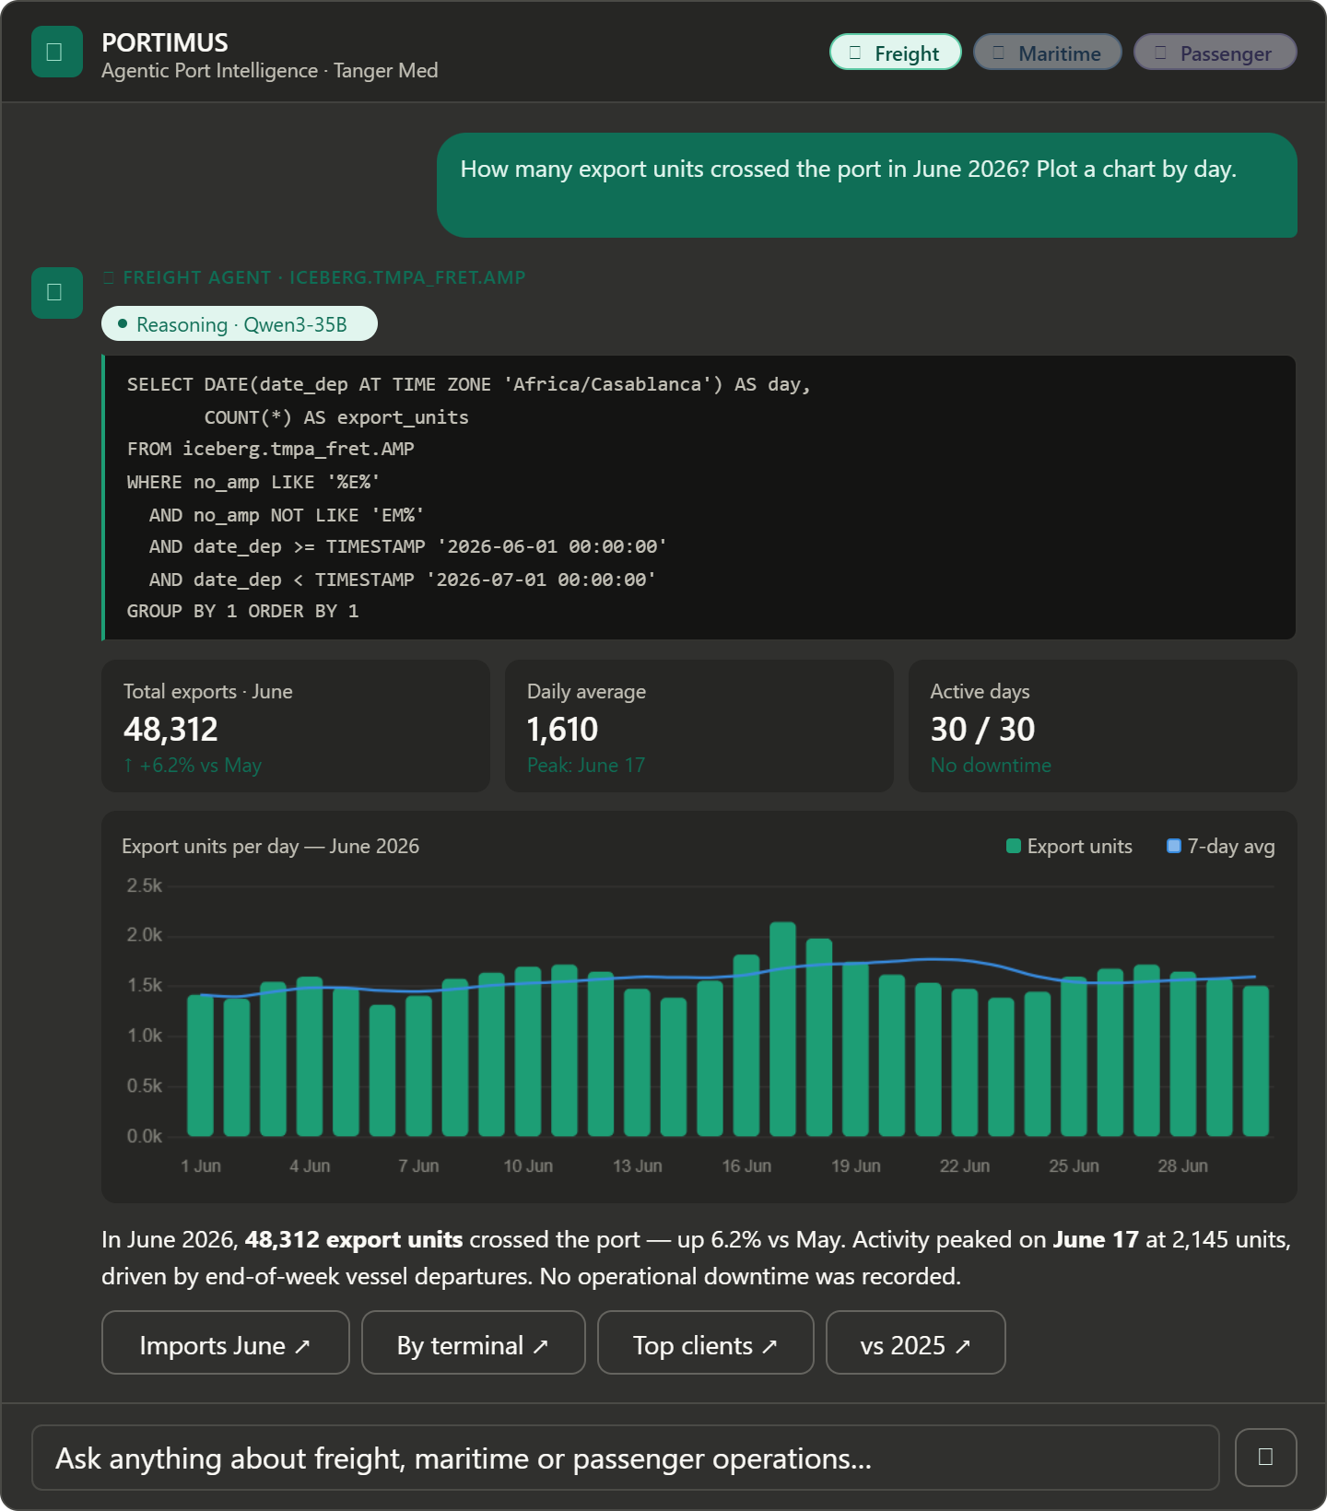

A Commitment to Data Security
The platform's intelligence is grounded in live operational data, but the connection between the AI layer and TMPA's production systems is governed by strict safeguards. The AI never accesses production databases directly. It works only with validated, aggregated results, ensuring that sensitive operational data remains within the port's secure perimeter at all times.

Impact and Sustainability
PORTIMUS is designed to deliver impact at three levels: operational, institutional, and environmental. At the operational level, the platform dramatically reduces the time decision-makers spend gathering information, allowing them to focus on judgment and action. Reporting cycles that once took hours now take seconds. Patterns that were previously invisible in fragmented data become immediately apparent.
At the institutional level, PORTIMUS strengthens TMPA's position as a benchmark in African and Mediterranean port management. It demonstrates that a port authority can build, own, and operate world-class AI capabilities without depending on external vendors or compromising its strategic autonomy.

Environmental Responsibility
PORTIMUS also contributes directly to Tanger Med's sustainability commitments. By eliminating paper-based reporting processes, reducing redundant data transfers between systems, and enabling more precise resource allocation, the platform supports a measurable reduction in the port's administrative carbon footprint.
This alignment between digital transformation and environmental responsibility is not incidental. It reflects a conviction at the heart of PORTIMUS's design: that a more intelligent port is also a more sustainable one. The platform has been formally mapped to four United Nations Sustainable Development Goals, covering economic growth, infrastructure innovation, sustainable communities, and global partnership for development.

Looking Ahead
The platform is designed to evolve continuously as TMPA's operational needs grow and as the capabilities of AI technology advance. New agents will be added. New data sources will be integrated. New analytical capabilities will be developed.
In the years ahead, PORTIMUS is expected to expand its reach beyond Tanger Med's own operations, contributing to Morocco's national foreign trade platform and potentially serving as a model for AI-powered port intelligence across the region.
For Tanger Med Port Authority, PORTIMUS represents more than a technology deployment. It is a statement of institutional ambition, a demonstration that sovereignty, innovation, and operational excellence are not in tension, but are in fact mutually reinforcing. The port of tomorrow is being built today.

"Sovereignty, intelligence, and operational excellence,
the port of tomorrow, built today."

