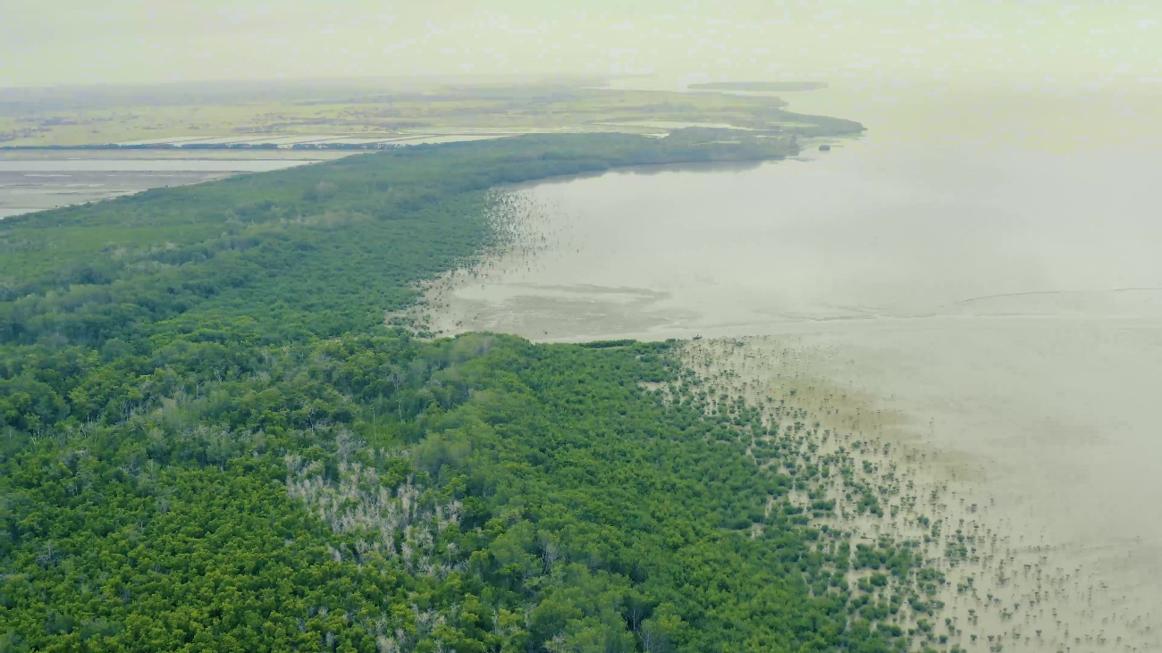

GENERATION OF MANGROVE ECOSYSTEMS IN ECUADOR AS PART OF DP WORLD BLUE CARBON STRATEGY

DP World Posorja S.A
Safety & Environment Department

Executive Summary
DP World Posorja (DPWP) as part of its global strategy "Our World, Our Future", and the Ocean Enhancement Program; on June 28, 2017, the former Deputy Secretariat of Coastal Marine Management (SGMC) part of the Ministry of the Environment and Water from Ecuador (MAAE). They issued the concession for mangroves in favor of DPWP to implement the Environmental Mitigation and Remediation Program (PMRA). The seedling selected to constitute the sowing substrate was the Red Mangrove (Rhizophora mangle).
Since then, DPWP began planting mangroves on 65 hectares (ha) with the Calisur Foundation in the Guayas province, Guayaquil canton, Puna Island sector, near the Zapote community. To date, in that area (65 ha), DPWP has planted more than 150,000 Red Mangroves.
DPWP completed the planting of 65 ha of mangroves and in order to reach the goal of 100 ha of mangrove planted. DPWP is carrying out an additional planting of a Red Mangrove in 40 ha in the Guayas province, Guayaquil canton, Puna Island, and Puerto el Morro sectors, which started in November 2020; 35,000 Red Mangroves seedlings have been planted. Then 65,000 of Red Mangroves seedlings will be planted until the year 2024.
The coastal ecosystems of mangroves contain large stores of carbon deposited by vegetation and various natural processes over centuries. These ecosystems sequester and store more carbon – often called "blue carbon" – per unit area than terrestrial forests. The ability of these vegetated ecosystems to remove carbon dioxide (CO2) from the atmosphere makes them significant net carbon sinks, and they are now being recognized for their role in the mitigation of climate change.
DPWP in the year 2024 estimates a reduction of 3'125,000 kg of CO2 from the 100 Ha of Red Mangrove Planting.

Generation of mangroves

Mangrove ecosystem
The mangrove ecosystem is the set of mangrove trees (Rhizophora sp.) That is in areas near the coast, mainly at the end of rivers, lagoons, estuaries, terrains with flat and muddy relief, periodically and partially flooded by relatively calm waters.
Mangroves are essential ecosystems and perform different functions at the service of human beings free of charge. Among the functions and values of mangroves, we can mention the following:
- They supply moisture to the atmosphere (a natural cooling source for nearby communities).
- They are producers of large amounts of oxygen and store large amounts of carbon.
- They are a source of organic and inorganic matter that sustains the estuarine and marine ecosystem.
- They support a considerable number of vulnerable or endangered species.
- They stabilize coastal lands against erosion, protect the coastline against hurricane-force winds and other high-impact weather events.
- They serve as regulators of the flow of rainwater, reduce the effect of floods.
- They are buffer zones against contaminants in the water.
- They are of great economic importance for commercial fishing, recreational and educational uses.

Sowing process

Collection and preselection of seeds
Red mangrove (Rhizophora mangle) seeds are collected by the "Cangrejeros" and Fishermen associations of the communities.
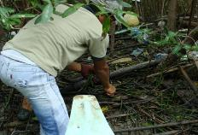 | 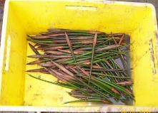

Sorting and discarding of mangrove seeds
The quality of the seeds is verified by visual inspection of chipping or the presence of perforations in the surface of the seed wall, which is a characteristic feature of the presence of pests (especially beetles).
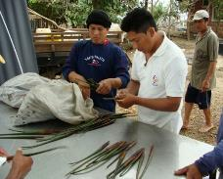 | 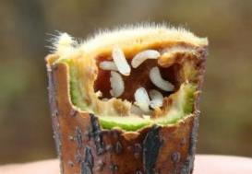

Germination
Once the seeds have been classified, they proceed with sowing in the germination beds. The sowing is carried out in 10 cm high black bags where the substrate (sediment) is placed to develop the roots.
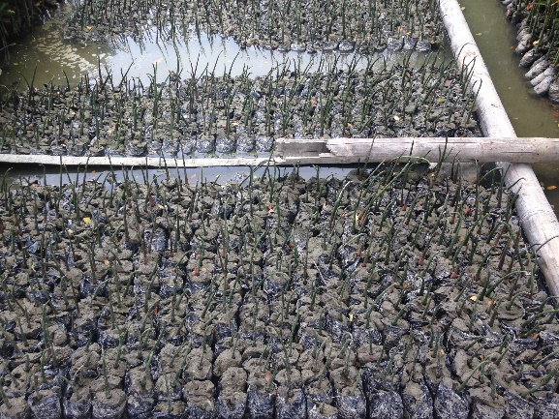 | 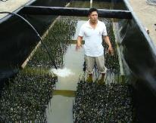

Sowing
The sowing activities were and will be carried out, as shown in the following table.
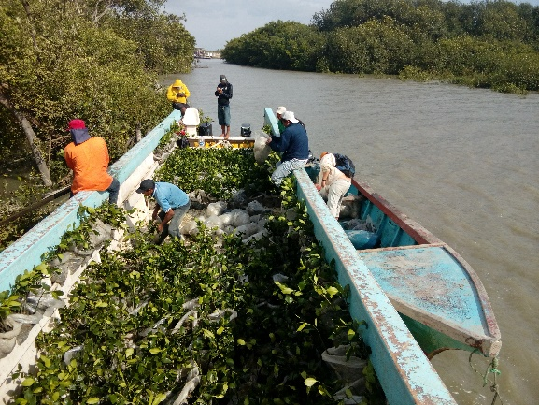 | 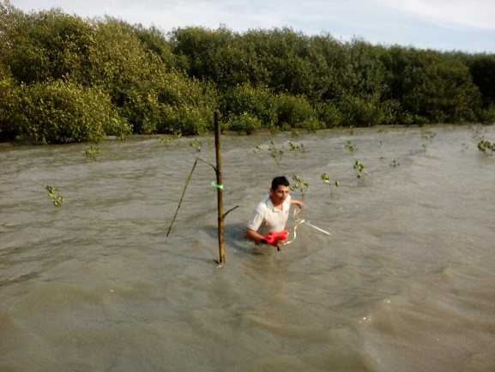

Table 1 Sowing schedule
PLANTING DATE | No. PLANTS
Area of 65 ha
July 2017 | 60,000 (planted)
September 2017 | 40,000 (planted)
Dec 2017 | 20,000 (planted)
September 2018 | 20,000 (planted)
September 2019 | 10,000 (planted)
Area of 40 ha
November 2020 | 15,000 (planted)
January 2021 | 10,000 (planted)
May 2021 | 10,000 (planted)
September 2021 | 15,000 (to be planted)
January 2022 | 8,000 (to be planted)
August 2022 | 10,000 (to be planted)
January 2023 | 8,000 (to be planted)
August 2023 | 8,000 (to be planted)
January 2024 | 8,000 (to be planted)
November 2024 | 8,000 (to be planted)
Total of plants | 250,000 (until 2024)

Therefore, since 2017:
- 150,000 red mangrove seedlings have been planted in the 65 hectares
- 35,000 red mangrove seedlings have been planted in the 40 hectares, and 65,000 more red mangroves will be planted until 2024.

Mangroves Monitoring
As part of the planting process, since the second semester of 2018, DPWP hired an environmental consultant to carry out annual monitoring to evaluate the functionality of the mangrove ecosystem in the 65 ha.
The summary of the monitoring carried out are presented below:

Flora

Mangrove growth
The number of seedlings present in each of the permanent plots was recorded.
During the monitoring, there was an increase in the number of seedlings per plot in relation to those inventoried in 2017. Due to the new scheduled plantings, there is evidence of recruitment of naturally regenerated species belonging to other mangrove species.
Considering the recorded data is concluded that the area of 65 ha has a density of 1,400 seedlings/ha.
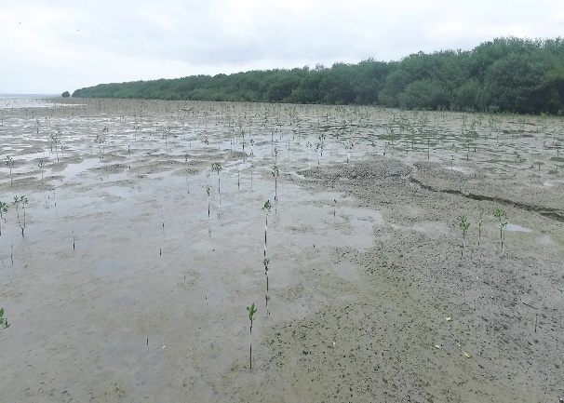 | 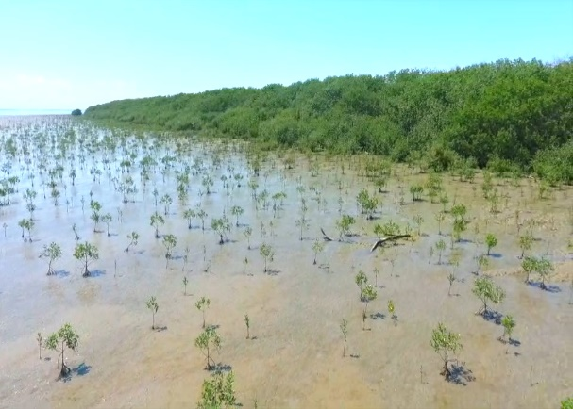
Planting area in 2017 (65 ha) | Planting area in 2018 (65 ha)
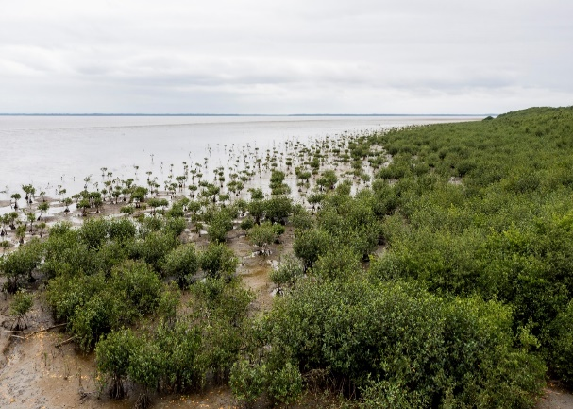 | 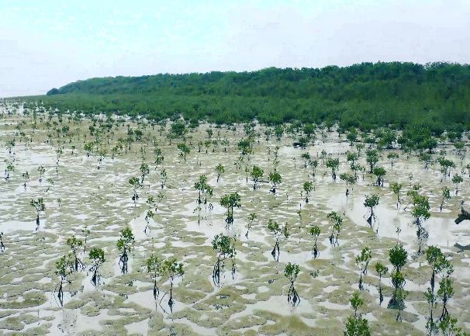
Planting area in 2019 (65 ha) | Planting area in 2020 (65 ha)
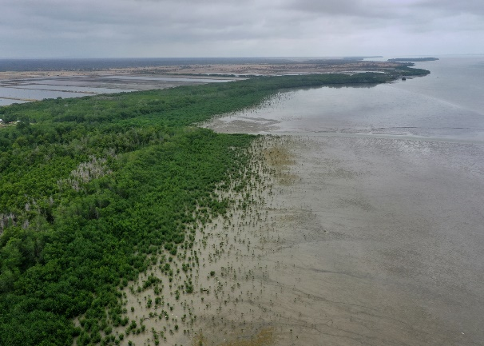
Planting area in 2021

Ichthyofauna
The objective of the ichthyofauna sampling was to determine the species of fish that enter or leave the planting area. The monitoring points were installed to cover different microhabitats generated by the different mangrove strata in the growth process.
During the monitorings, different species in the water column were recorded: from pelagic, benthopelagic, and benthic fish.
The study area is in constant morphological change mainly due to the effect of the tides. For example, high tides cause predatory species to enter the mangrove to feed, unlike low tides where the largest number of species and individuals are juveniles are found in refuges where they ensure their survival.

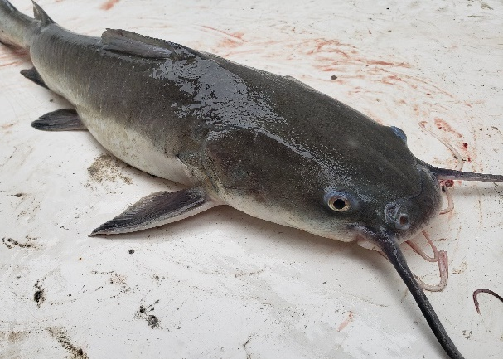 | 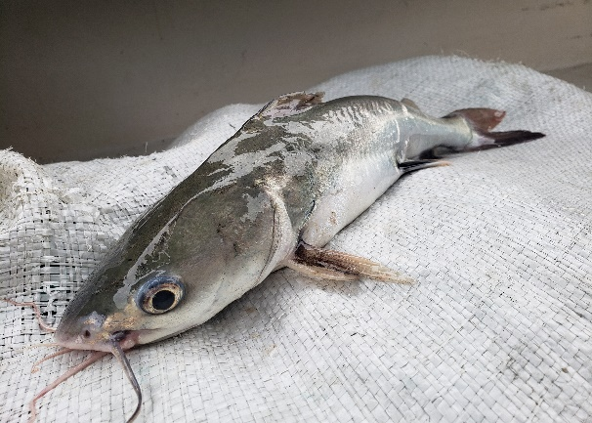
Notarius kessleri | Ariopsis seemanni

Marine Macroinvertebrates
The benthic macroinvertebrate samples were taken from the surface layer of the sediment (0.5 cm) at high tide. The replicas were taken in very close areas, considering the same type of sediment, so that the sampling is as homogeneous as possible.
Mangrove planting results; demonstrate remarkable achievement in creating microhabitats with favorable conditions for the development of aquatic macroinvertebrates.
As part of the monitoring, the dominant species in the samples were the Polychaetes group, organisms that play a significant role in the function of benthic communities as biological indicators. Due to their reuse characteristics of marine sediments and compaction of organic matter, the oxygen and temperature values are essential in its ecological functions.
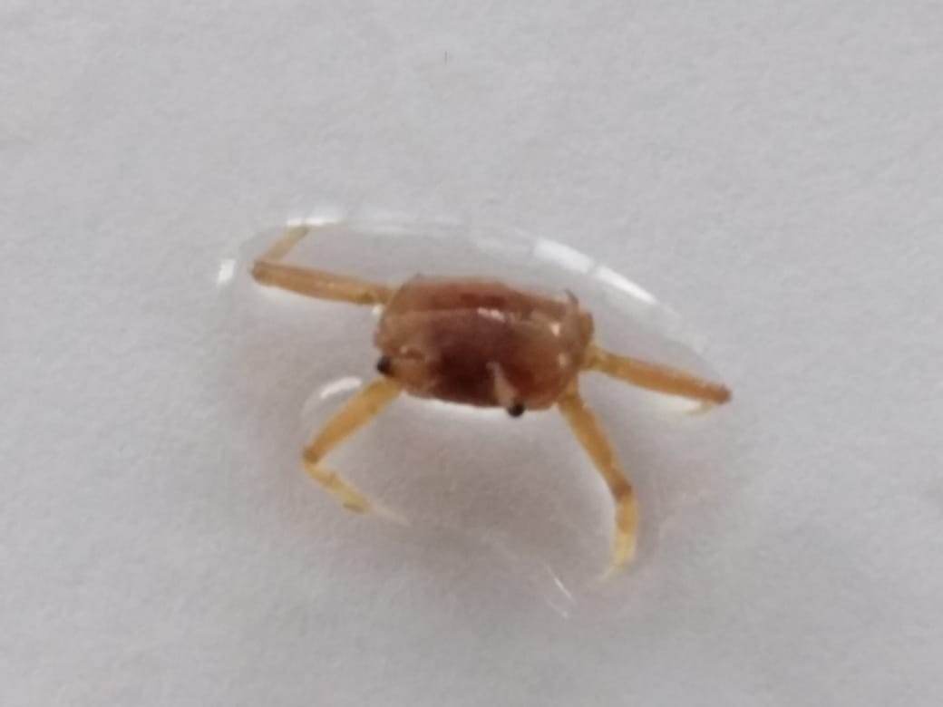 | 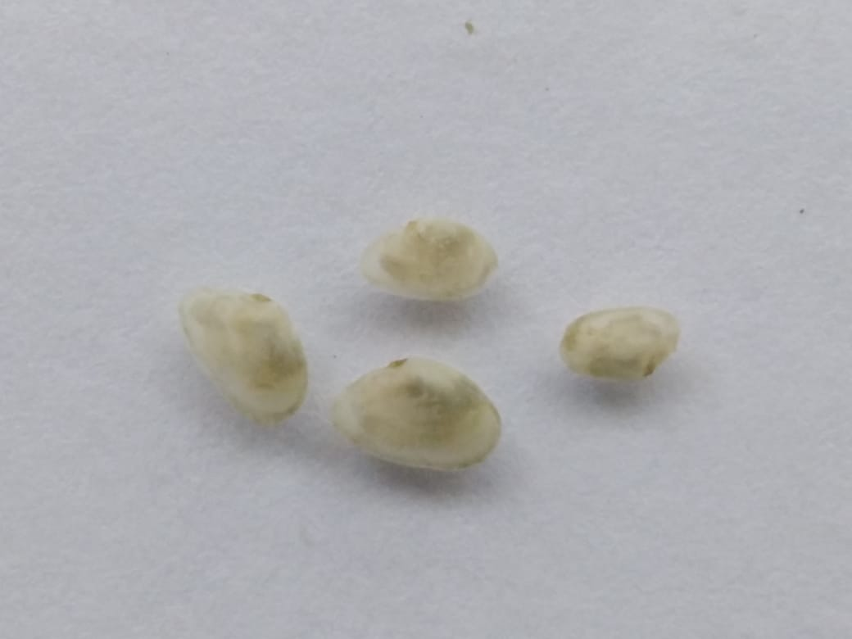
Ocypode sp. | Tellina sp.

Limnology
The mesotrophic state of the monitoring area has been based on the presence of an abundance of phytoplankton species and zooplanktonic species. Copepods were the dominant group representing 66.6% of the total zooplankton organisms in the study area.
According to the results, it can be concluded that the reforestation process is satisfactorily carried out. Since there are no alterations in the planktonic communities, on the contrary, there is evidence of balance in the communities, an increase in abundance, and the absence of indicators of alterations in the marine ecosystem.
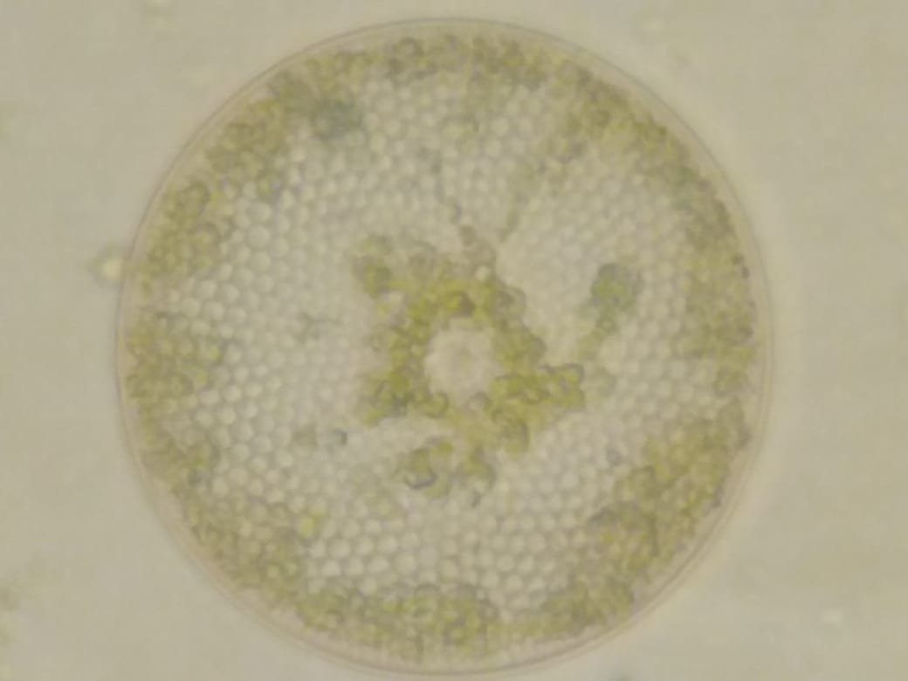
Coscinodiscus excentricus | Triceratium favus

Blue Carbon
The coastal ecosystems of mangroves contain large stores of carbon deposited by vegetation and various natural processes over centuries. These ecosystems sequester and store more carbon – often called "blue carbon" – per unit area than terrestrial forests. The ability of these vegetated ecosystems to remove carbon dioxide (CO2) from the atmosphere makes them significant net carbon sinks, and they are now being recognized for their role in mitigating climate change.
Coastal ecosystems need to be conserved and restored as globally significant carbon sinks, despite their small extent relative to other ecosystems. They sequester and store globally significant amounts of carbon in their soil. The ongoing destruction and loss of these systems contribute to additional human-induced greenhouse gases. Alongside tropical forests and peatlands, coastal ecosystems demonstrate how nature can be used to enhance climate change mitigation strategies. They, therefore, offer opportunities for countries to achieve their emissions reduction targets and Nationally Determined Contributions (NDCs) under the Paris Agreement.
According to the consulted bibliography, approximately one mangrove tree removes 308 kg (0.3 tonnes) of Co2 from the atmosphere over its growth life, which is 12.3kg per year.
0.3 tonnes per tree is the same as:
- Driving 732.9 miles in a standard car
- Flying from London to Monaco
Following the estimate of CO2 that will be sequester within the 100 ha of red mangroves, that will be planted until 2024.

Table 2 Estimate of Co2 Sequester
 | Units | Equivalent in Carbon Dioxide (Co2) | 2021  (200,000 mangroves planted) | 2022  (200,000 + 18,000 mangroves to be planted) | 2023  (218,000 + 16,000 mangroves to be planted) | 2024  (234,000 + 16,000 mangroves to be planted)
Carbon per Tree planted | Kg of CO2/ year (average) | 12,5 | 2 500,000 | 2 725,000 | 2 925,000 | 3 125,000

Program Dissemination
DPWP, since the construction phase in 2018, started the dissemination of the project and engaged the workers in the mangrove planting as part of the GoGreen Week event where DP World celebrates every year in September. We plant about 2,000 red mangrove seedlings (1 Ha) every year, meaning that we can plant about 50 Ha more during the concession.
Following, DPWP KPI and some photo records from GoGreen events.
Table 3 GoGreen KPI (2018 – 2021)
Year | No. plant planted | Number of volunteers | Number of hours spent | Hectares
2018 | 500 | 15 | 4 | 0,5
2019 | 1,000 | 90 | 4 | 1
2020 | 2,000 | 100 | 4 | 2
2021 | 2000 | 100 | 4 | 2

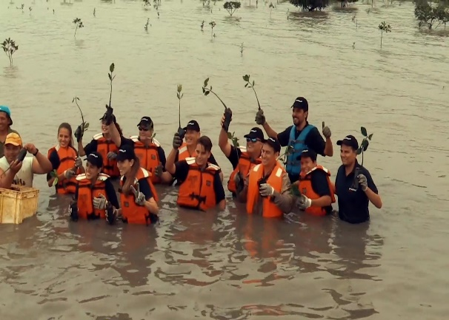 | 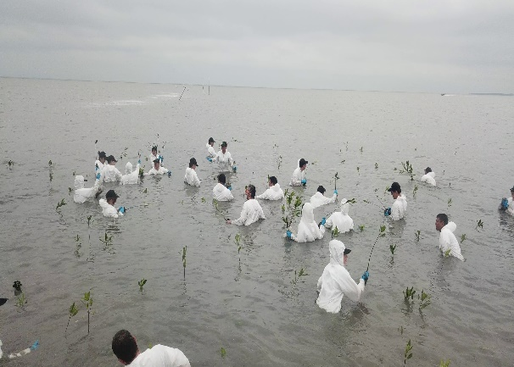
Go Green 2018 | Go Green 2019
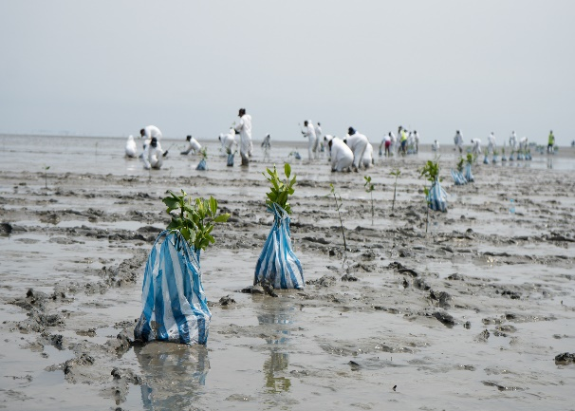 | 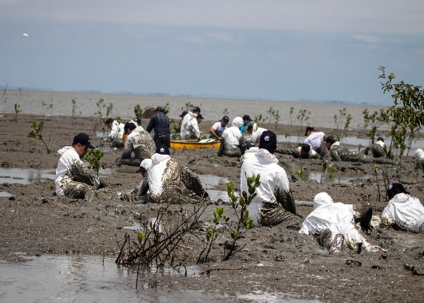
Go Green 2020 | Go Green 2021

