IAPH/WPSP 2021 Sustainability Awards
Project Information
Port | Maritime and Port Authority of Singapore
Country | Singapore
Project title | Singapore Digital Port Ecosystem
Phone | +65 90030895
Email | FOO_Chi_Jao@mpa.gov.sg
Relevance of the project to the WPSP areas of interest | Resilient Infrastructure
Start year | 2020
End year | Not applicable

Short Description (300 words)
Maritime digitalisation is vital to business competitiveness and international trade. By rapidly digitalising maritime trade, it can also catalyse innovation and yield greater operational efficiency in the maritime transport chain.
The Maritime and Port Authority of Singapore (MPA) recognises that digitalisation is a key driving force that will help transform the industry and secure Singapore’s position as a leading international maritime centre. Hence, the MPA has implemented initiatives such as:
- Singapore Maritime Data Hub (SG-MDH) is a data sharing and digital connectivity platform for industry/technology partners to collaborate and integrate their systems to catalyse the development of innovative solutions for the maritime industry to enhance operation efficiency and productivity.
- digitalPORT@SGTM (Portal for One-stop Regulatory Transactions) is Singapore's maritime single window to enable more efficient, seamless and integrated port services, and will pave the way for further digitalisation of port and marine services.
- digitalOCEANSTM (Open/Common Exchange And Network Standardisation) fosters interoperability between digitalPORT@SGTM and other digital platforms through the use of common data standards and Application Programming Interfaces (APIs).
Together, they form the core of Singapore’s digital port ecosystem, where SG-MDH is the backbone for data infrastructure supporting the services in digitalPORT@SGTM, while digitalPORT@SGTM is the key node for digital connectivity from the Port of Singapore, and digitalOCEANSTM provides data and API standards to foster interoperability with other digital platforms. The digital port ecosystem helped to reduce the administrative burden of shipmasters in port call and reporting formalities, allowing them to focus their attention on their primary responsibility of navigating ships safely. It has also helped to save an estimated 100,000 man-hours per year for the industry. New services such as crew change application and Just-in-Time services are also being rolled out as MPA continues its efforts to drive the transformation of the maritime industry during the COVID-19 pandemic.
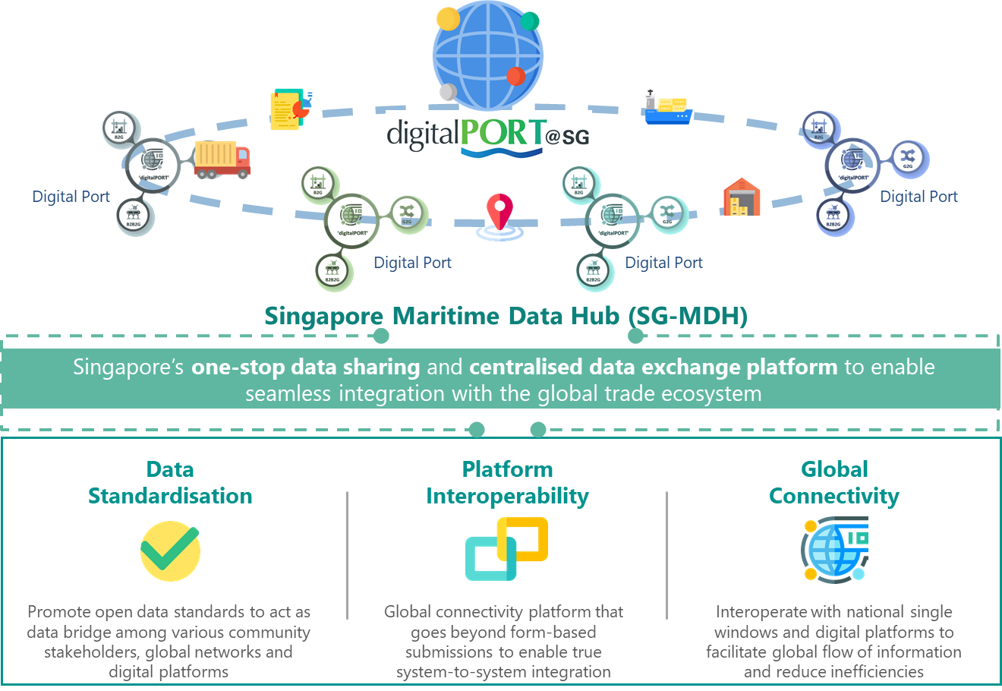
Diagram 1: Overview of Singapore Digital Port Ecosystem
Singapore Maritime Datahub
Data fuels digitalisation and is a key enabler to drive Singapore’s maritime digitalisation efforts. In April 2019, MPA launched the Singapore Maritime Datahub (SG-MDH) to be a one-stop data sharing and digital connectivity platform for industry, government agencies and technology partners to co-create innovation applications and integrate their systems and services with the objectives to enhance operation efficiency and effectiveness.
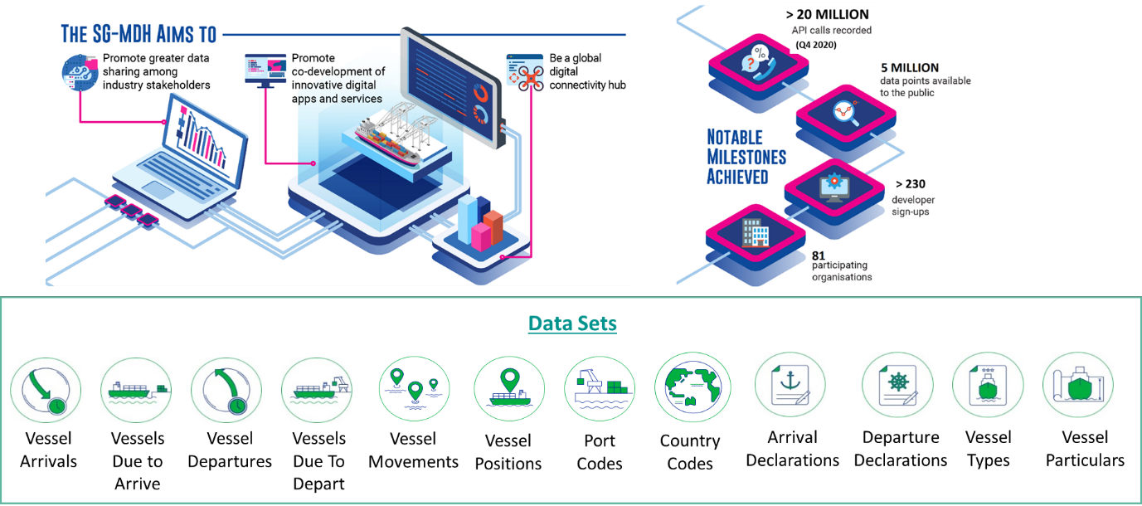
Diagram 2: Overview of Singapore Maritime Datahub (SG-MDH)
With more than 5 million data points available to the community, the SG-MDH initiative has gained traction in the industry where it attracted a diverse pool of developers and companies to come onboard. In addition, the SG-MDH has recorded more than 40 million API calls as of 1Q 2021, averaging at about 3 million calls per month. The SG-MDH is the first maritime data hub by a port authority and the 40 million of API calls recorded since it was launched underpins the importance of data and how data sharing could be enabled with the industry to fuel innovation and transformation.
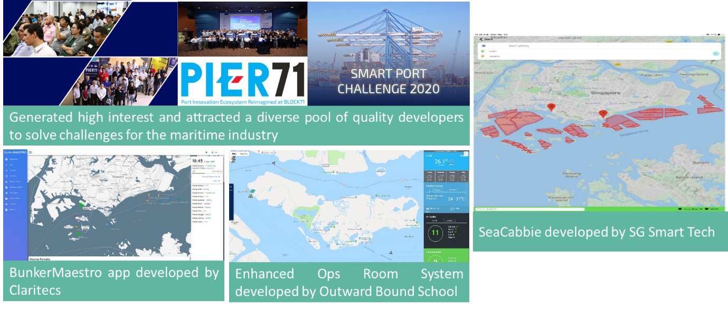
Diagram 3: Use cases for Singapore Maritime Datahub (SG-MDH)
The SG-MDH also serves as a backbone for data infrastructure to support the digital services in digitalPORT@SGTM, where it will store MPA data and exposes it via API for other trusted digital platforms to consume and interoperate, thereby greatly reducing the need for manual intervention which enhances operational efficiency and effectiveness.

digitalPORT@SGTM
When ships call at the Port of Singapore, ship masters/agents need to fulfil regulatory port entry requirements by submitting information of the ships, its crew and passengers, and health declarations to the Maritime and Port Authority of Singapore (MPA), the Immigration and Checkpoints Agency (ICA) and the National Environment Agency (NEA) for clearance respectively.
Following implementation of a new digitalised port clearance process under the digitalPORT@SGTM maritime single window platform in Sep 2020, ship masters/agents now do not need to submit common/repetitive information and liaise separately with the 3 agencies for their clearance application status. digitalPORT@SGTM has streamlined up to 16 different submission forms into one application that is processed and updated by all 3 agencies centrally. It has reduced the administrative burden of the shipmasters in port call and reporting formalities, and allowed the ship masters to focus on their primary responsibility of navigating their ships safely.
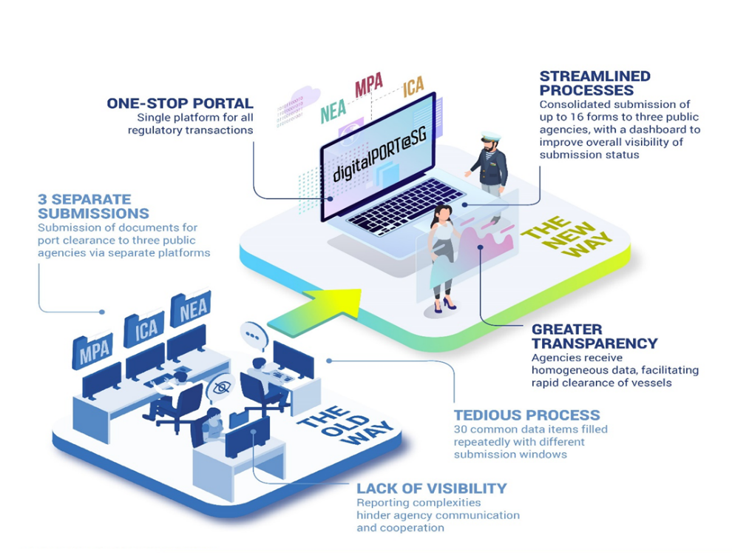
Diagram 4: Overview of digitalPORT@SGTM
digitalPORT@SGTM and its impacts to the maritime industry during COVID-19 pandemic
The COVID-19 pandemic had caused severe disruption to shipping operations around the world and many shipping companies have been undergoing tremendous stress with the global travel restrictions and stricter conditions for crew and port health clearances.
Many in the industry would have thought that the rollout of a new digitalPORT@SGTM platform during the pandemic period would have taken a backseat or even be postponed. Instead, MPA pressed on and expedited it during Phase 1 and 2 of Singapore’s COVID-19 “Circuit Breaker” period to simplify the port clearance process for ships that call at the Port of Singapore to ensure that movement of essential goods and food supplies continue to flow and reach the Port of Singapore promptly. This was done with the trust established with the industry and lowering of the administrative burden of ship masters and agents which allowed them to better cope with the new normal. digitalPORT@SGTM would also eliminate the need for physical interactions between agents and shipmasters, to ensure adherence to safe distancing measures during the pandemic.
With global border and travel restrictions, many seafarers were kept apart from their families for a prolonged period as they were unable to leave their ships. As a responsible port and leading international maritime centre, MPA supported the call by international organisations such as International Transport Workers Federation (ITF) and International Maritime Organisation (IMO) to allow crew change to avoid a humanitarian crisis and ensure the welfare of the ship crew is taken care off, especially during a pandemic.
MPA worked tirelessly with many government agencies, unions, and the shipping industry to facilitate and support crew change. This is where shipping agents could submit a preliminary request for crew change if they meet the criteria defined by MPA. To date, MPA has processed more than 150,000 crew change applications since 27 Mar 2020. The Singapore Crew Change Guidebook, which details a set of procedures for a “safe corridor” to allow crew change to be carried out in a safe environment, was published to help in minimising health risk to the public and the shipping community.
With more efficient port clearance and new crew change processes, digitalPORT@SGTM has enabled cost avoidance/savings to businesses and government agencies in terms of the application submissions and processing time. It is estimated to save the industry over 100,000 man-hours annually just for port clearance itself.
As a frontline agency responsible for safeguarding the sea check-points under the Ministerial Task Force for COVID-19, the completion of the roll-out of digitalPORT@SGTM to more than 2000 companies in Sep 2020 is a testament to our commitment to improve the ship reporting process and innovate a crew change process to safeguard the welfare of the ship crews, workers and staff in the maritime industry. These efforts reinforce Singapore’s efforts, along with international organisations, to support shipping and seafarers during the pandemic.

digitalPORT@SGTM Phase 2 – Single Integrated Digital Platform and Just-In-Time Services
Under phase 2 development, digitalPORT@SG™ will be enhanced to a single integrated digital platform for the industry to facilitate the booking of marine services from service providers. It will also provide Just-In-Time (JIT) services from a port-centric approach for all stakeholders in the maritime value chain to facilitate direct berthing on arrivals and on-time departures to reduce wait time at anchorages as well as to enhance ship turnaround time in the planning and scheduling of port resources. With the improvement in efficiency and faster turnaround of port stays, the carbon footprint generated by ships would be reduced due to shorter port stays. This is aligned with United Nation's Sustainable Development Goals on Life Below Water by reducing the marine and ecosystems pollution. digitalPORT@SGTM will also enable the sharing of ship and port documents between port administrators and maritime stakeholders, thereby facilitating data convergence in the global maritime transport value chain.
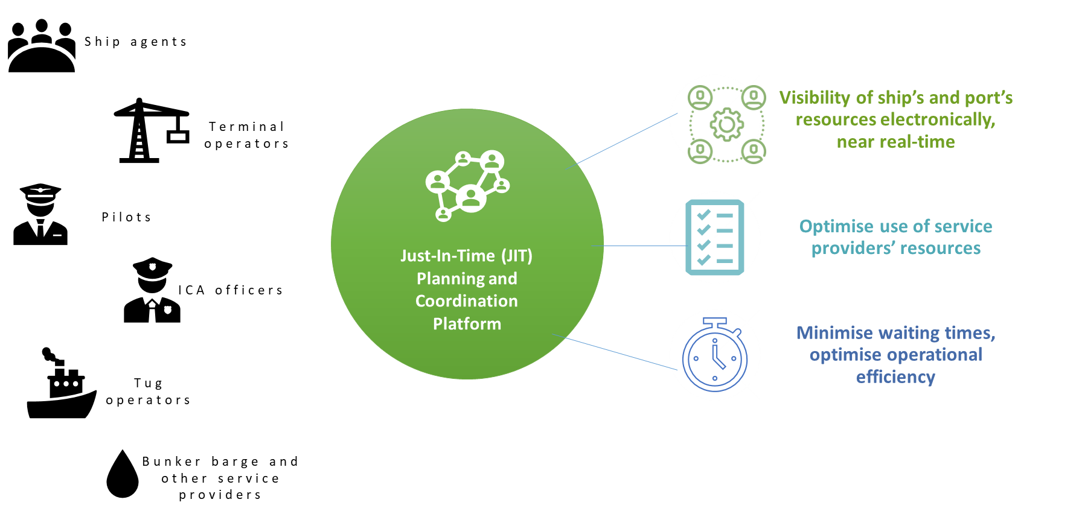
Diagram 5: Overview of digitalPORT@SGTM Phase 2

digitalOCEANSTM
With the requirement for national governments to introduce electronic information exchange between ships and ports under the FAL Convention, and the proliferation of “single window” solutions and various global logistics supply chain platforms, there is an urgent need for system level interoperability among these digital platforms to enable an integrated maritime transport chain and seamless digital experience for all users.
To foster interoperability between digitalPORT@SGTM and these platforms, Singapore launched the digitalOCEANS™ initiative on 28th July 2020 with like-minded partners and industry players to advocate data exchange through the use of Open or Common Exchange And Network Standardisation with common data standards and application programming interface specifications. This addresses some of the barriers to data exchange, such as the financial cost of adopting a universal software platform, as well as security concerns over the hosting of sensitive data off-site or in the cloud. The digitalOCEANS™ initiative serves as the digital ‘bridge’ between shipping companies, supply chain and logistics companies, port authorities, etc. to facilitate seamless port-to-port connectivity, enabling effective information exchange and efficient transactions across the maritime transport chain.

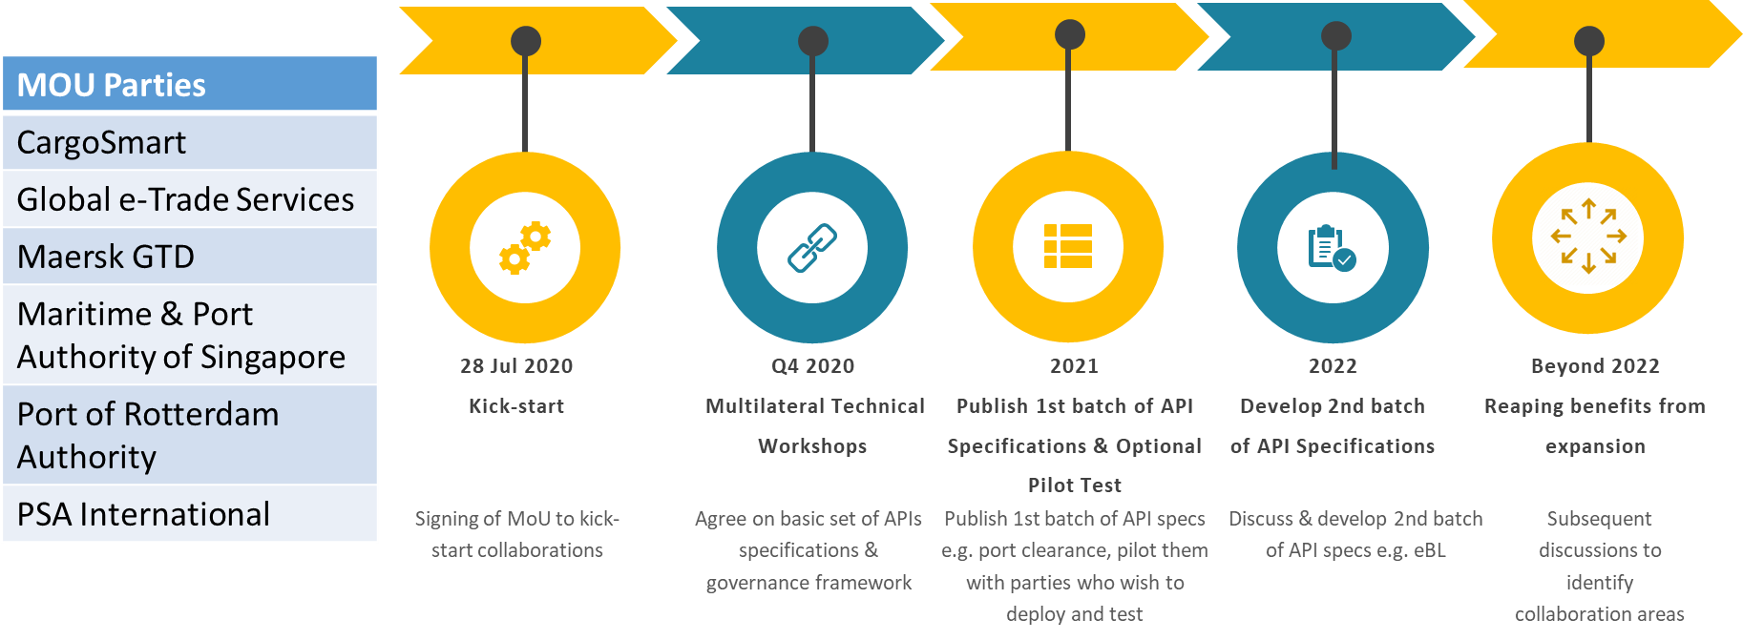
Diagram 6: Partners and timeline for digitalOCEANSTM
Cyber Resiliency
With increased digitalisation, cyber security and resiliency became equally important to ensure that the digital systems and data are resilient, secured and safe from cyber-threats. In this respect, both the SG-MDH and digitalPORT@SGTM were developed based on security-by-design methodology that addresses security considerations and requirements upfront during the design and development stages of the project. All relevant security controls and measures are also put in place to ensure system security and protection against cyber threats. In terms of network and security architecture, both the SG-MDH and digitalPORT@SGTM were also designed and built to segregate between the intranet and internet zones to mitigate cyber threats and prevent exfiltration of data.

