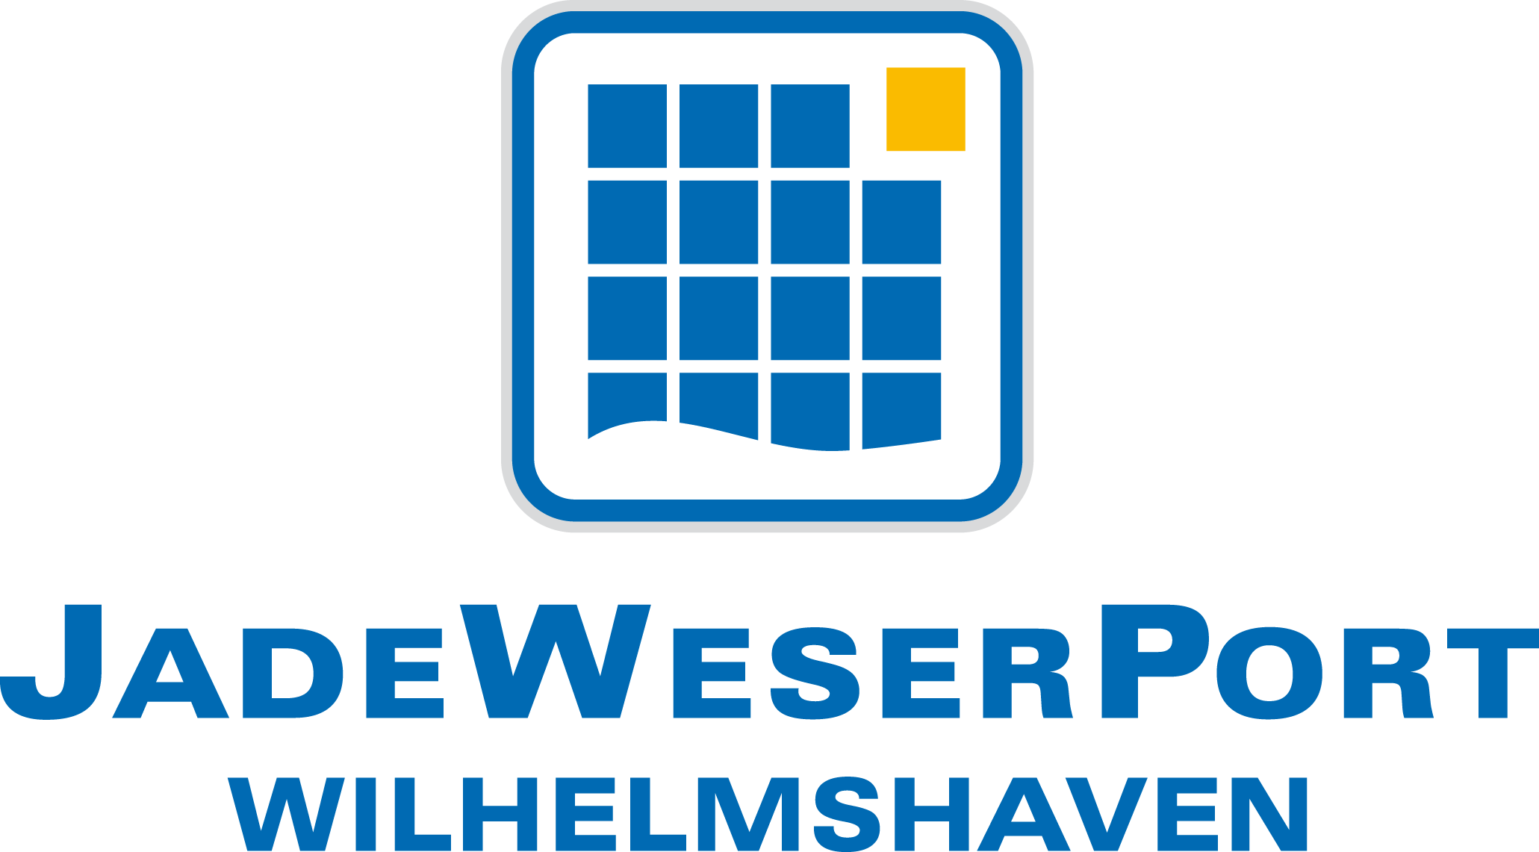

Innovative and environmentally friendly Hydrogen Applications in Seaport Emden (WASh₂Emden)

Project Overview

13/02/2019

General overview
The aim of the “WASh2Emden” project is to study the technical and economic feasibility of converting the port of Emden into an energy-hub, that; relies on renewable energy based on hydrogen, in addition to supplying and distributing ‘green’ hydrogen to the region. The seaport of Emden will serve as a real laboratory for experimenting the innovative and environmentally friendly Hydrogen Applications, with the goal of reducing the emissions from; port operations, logistics in port and the hinterland, and from vessels calling the port.
Various supply/storage options are being investigated and assessed from technical, logistical and economical point of views. Supply options include but are not limited to utilizing the regionally available surplus electricity of wind farms, which is very abundant around the Emden region and is currently not being used due to network bottlenecks. The storage of surplus electricity in the form of hydrogen can contribute effectively to the energy transition and to the reduction of the port’s carbon footprint.
The Consortium comprises 5 partners; Niedersachsen Ports (the lead partner of the project), Tyczka, DBI Gas- und Umwelttechnik, abh Ingenieur-Technik, and MARIKO.
JadeWeserPort & Niedersachsen Ports teams are working jointly together on exploring the potentials of using hydrogen in ports.
A comprehensive feasibility study will be carried out in six work packages with 25 measures, over an 18-month project period. The work packages are each led by a project partner. The lead partner NPorts leads two work packages, the other four partners each one. If the results are positive, the project will be the starting point for Emden's development into a “hydrogen port”; in Germany. A demonstration of a green hydrogen supply chain is planned to follow the feasibility study.
The project is supported by the Innovative Port Technologies (IHATEC) funding program of the Federal Ministry of Transport and Digital Infrastructure (BMVI).
The project external kick-off is on February 21st, 2019.

Problem Description
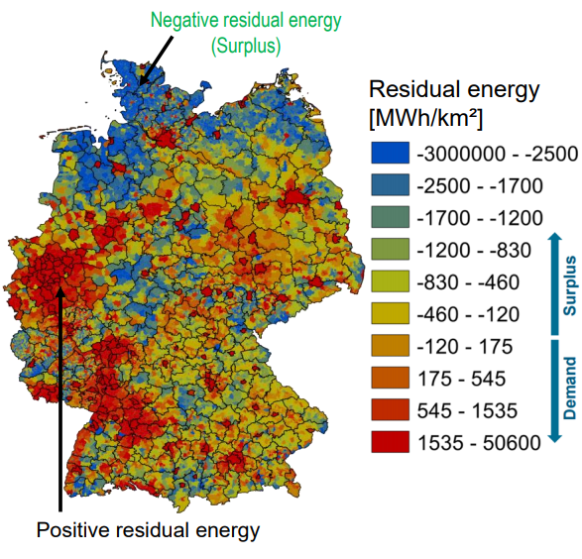
Northern Germany is a region that has a large amount of negative residual energy (surplus electricity) generated by renewable sources and is not fed to the grid due to network bottlenecks, as shown in figure 1. The Transmission System Operators (TSO) are bound by the Renewable Energy Act (EEG) to cut down their production in time of low demand in return for a compensation for the incurred financial losses according to Hardship clause of the same act.
Figure 1: Residual Energy Map of Germany
In addition to that, the current energy consumption and emission values for the port of Emden are high. The port infrastructure operator NPorts alone consumes around 5,000,000 kWh of energy per year and emits 1,600 tonnes of CO2. That was the starting point for the project “WASH2Emden”.

Aims of the project
The “WASh2Emden” project aims to develop a new utilisation and storage solution for the problem of excess wind power, which is caused by the fluctuating power generation in wind energy and has not been satisfactorily solved so far (preliminary agreements have been made with the Emden municipal utilities for the provision of excess wind power). The project can contribute to relieving the burden on electricity grids and integrating renewable energies in the sense of energy system transformation, as well as, reducing emissions from different port activities.
The hydrogen available in the port could then be used in;
- Emission reduction in land-based port operations and logistics;
- Emission reduction from ships in port
The project investigates using highly efficient fuel cell systems, as well as internal combustion engines. Also, other hydrogen supply methods are being investigated in the project, as shown in figure 2. A comprehensive feasibility study will be carried out over an 18-month project period, which will be followed by a real demonstration, if it deemed to be successful.
The project has a particular focus on supplying shore-side electricity to ships. Nordkai (North Quay), on the premises of the port handling company EPAS, is designated for supplying ships with Shore-side electricity (preliminary arrangements have been made with shipowners/managers).
The perspective goal is to develop and implement a “zero emission”; energy supply and port logistics system using an innovative wind-hydrogen system with the most economical storage solution. Behind this is the overriding goal of converting the port infrastructures in Germany to the “post-carbon age”; as early as possible in accordance with the results of the climate protection conferences. These provide for the decarbonisation of the economy with the inclusion of all sectors. This also includes the significant reduction of emissions of local air pollutants (SOx, NOx and particulate matter) and climate gases (including CO2) in port areas.

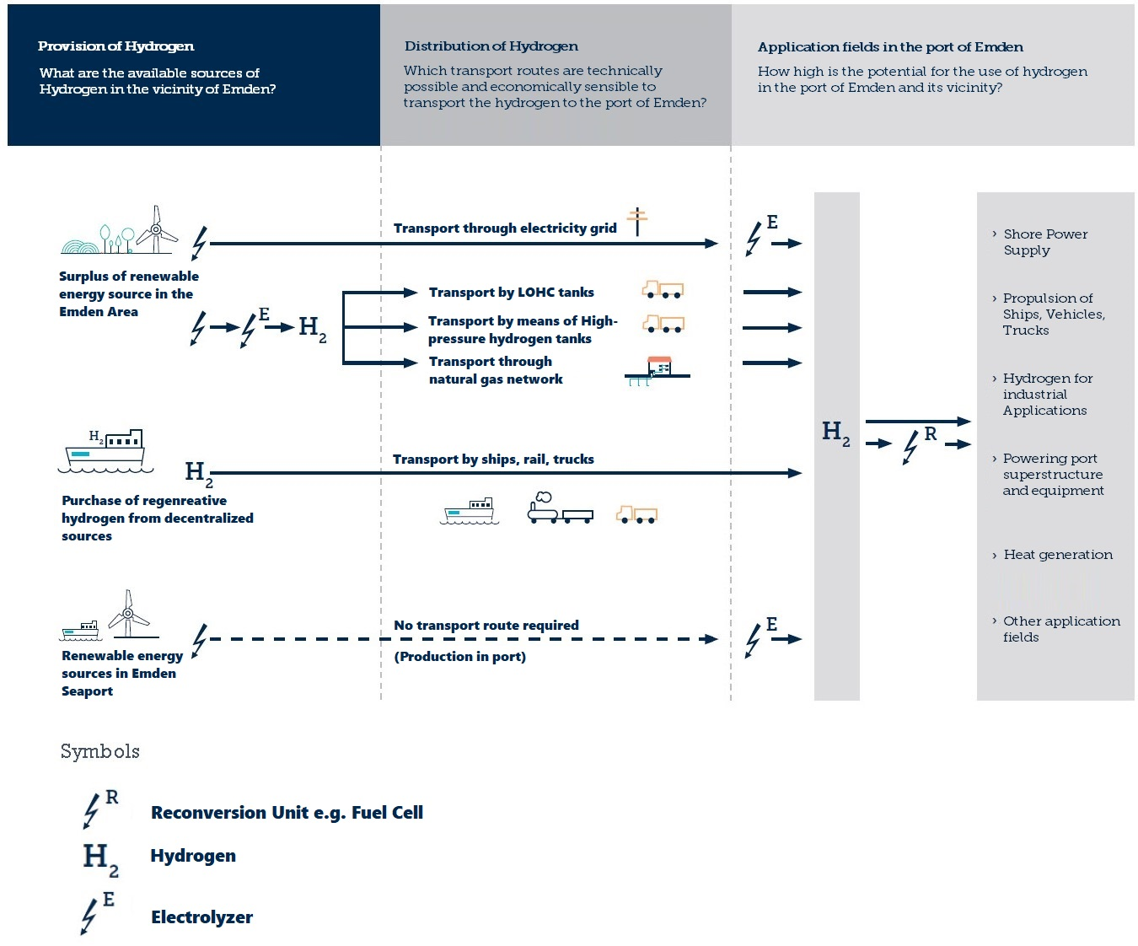
Figure 2: Hydrogen supply chain

